## Report on Investigating the Policy:

We detected a problem that if at stage k=0 the policy seems to be idle (u=0) much more than it should be. As the queues are all empty, the policy should take an action that would assign the job to one of the queues.

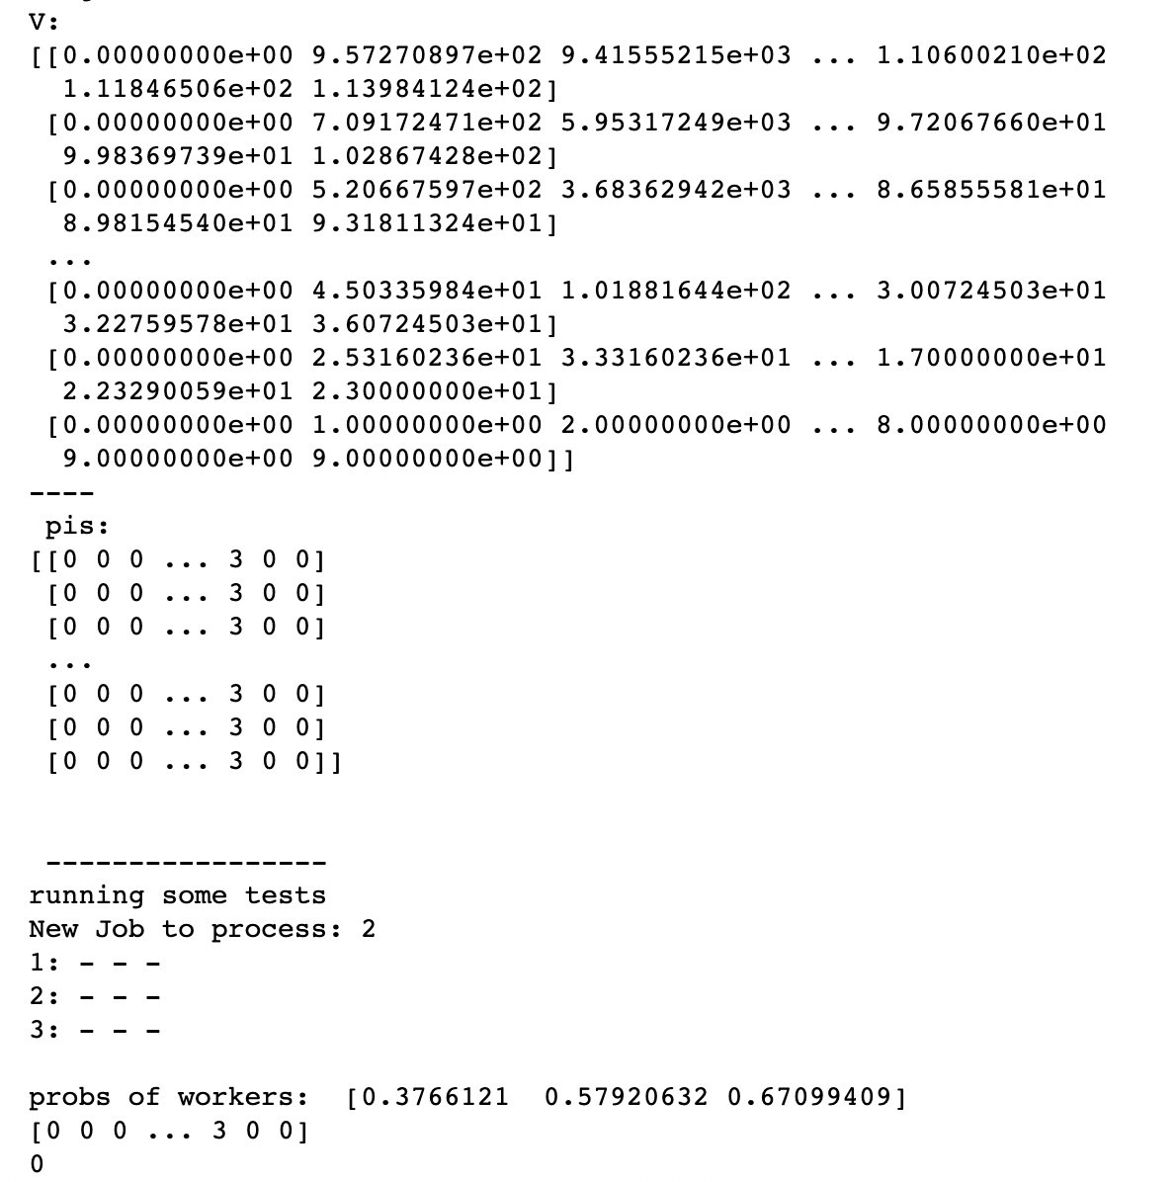

Moreover, we can compare stage k=0 and stage k=9:

Stage **k=9**:

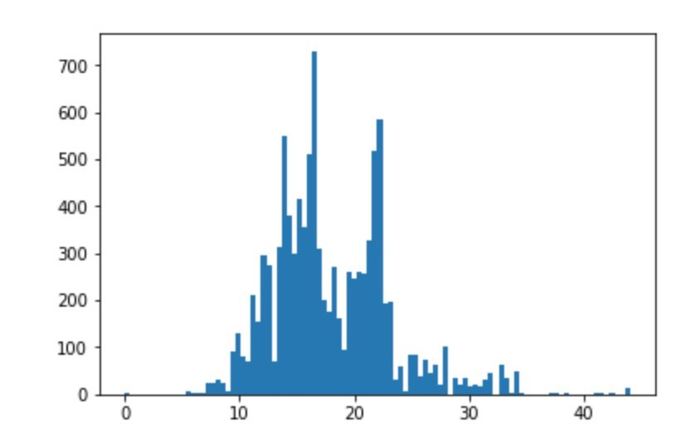

We have a well distributed Value function.

For stage **k=0** we get:

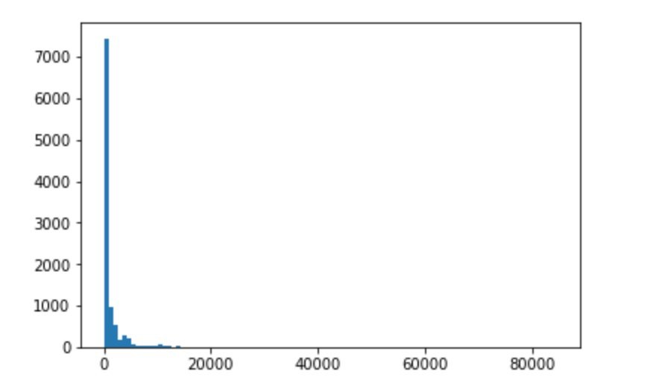

Which shows that our value function not properly converges. The probabilities are probably not normalized properly.

Investigating the Policy for 250 iterations

The local costs at the stage **k=9** are:

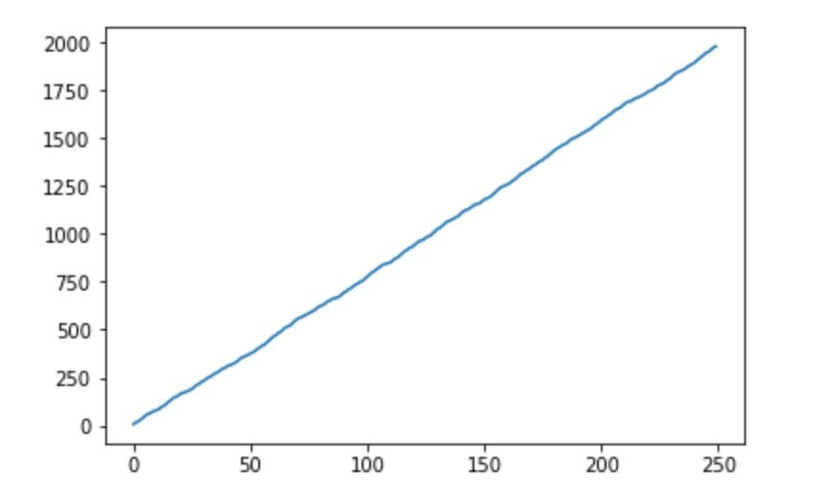

It can be seen the policy is not that good evolved since it only had a lookout of one stage in advance.

If we compare this to the first stage **k=0**:

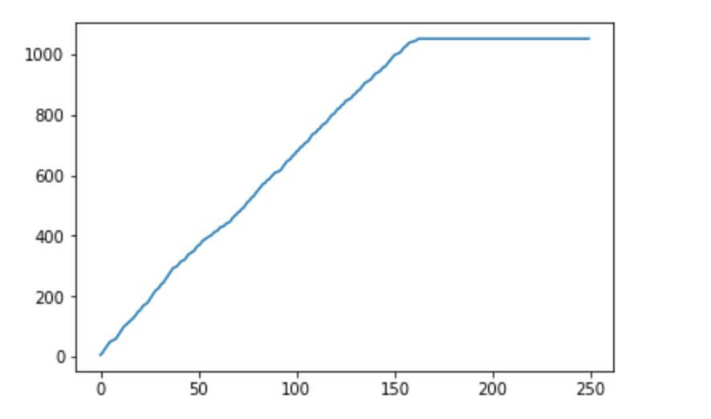

The policy here converges for more iterations since it also takes the future stages into account.